MS SQL SERVER
Standard Operating Procedures
(SOP)

Setting up Windows Service Accounts

Submitted to



By



CIS, Wipro Limited

Document Details

Project Name | Innogy SE
Account | CIS
IT Component/Application Title | Setting up Windows Service Accounts
Current Version | 1.5
List of Contributors | Pradipkumar Kansara, Kiran Bhalekar, Ayushi Gautam, Sivakumar Goud, Ayushi Srivastava
Customer Contact Information

Version History
(All revisions made to this document must be listed in chronological order. All revisions must be approved. Review and Approval can be done by an internal source or by the customer)
Version | Date of Revision | Description | Author | Reviewed By | Approved By
1.0 | 29-08-2015 | Initial Draft | Kiran Bhalekar | Pradipkumar Kansara | Mahesh Keshatwar
1.1 | 04-09-2015 | Document Completed | Kiran Bhalekar | Pradipkumar Kansara | Mahesh Keshatwar
1.2 | 24-08-2016 | Updated document to standard format | Ayushi Gautam | Pradipkumar Kansara | Mahesh Keshatwar
1.3 | 20-05-2017 | Wipro and Innogy Logo changed | Sivakumar Goud | Pradipkumar Kansara | Mahesh Keshatwar
1.4 | 29-08-2017 | Updated document to Wipro Standard format with header and footer | Kiran Bhalekar | Pradipkumar Kansara | Santosh Badiger
1.5 | 18-12-2018 | Updated the content | Ayushi Srivastava | Pradipkumar Kansara | Santosh Badiger

Document Distribution List
S.No | Name and Company | Purpose
1 | RWEIT-SQLDBA | This document is for how to setup windows service account in SQL
2

TABLE OF CONTENT

1. Purpose 1
2. Scope 1
3. Setting Up Windows Service Accounts 1
4. Reference 2

Purpose
This document is prepared Setting up Windows service Accounts in SQL Server Database Administration Services at <Customer Name>.

Scope
This document is prepared for GSMC Wipro sustenance team and provides the concepts of Setting up Windows service Accounts for the administration of the SQL Server database at <Customer Name>.

Setting Up Windows Service Accounts
Each service in SQL Server represents a process or a set of processes to manage authentication of SQL Server operations with Windows. This topic describes the default configuration of services in this release of SQL Server, and configuration options for SQL Server services that you can set during SQL Server installation.
Depending on the components that you decide to install, SQL Server Setup installs the following services:
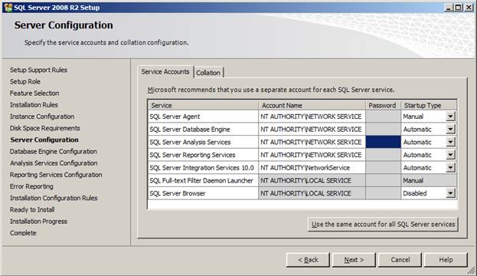
- SQL Server Database Services - The service for the SQL Server relational Database Engine.
- SQL Server Agent - Executes jobs, monitors SQL Server, fires alerts, and enables automation of some administrative tasks.
- Analysis Services - Provides online analytical processing (OLAP) and data mining functionality for business intelligence applications.
- Reporting Services - Manages, executes, creates, schedules, and delivers reports.
- Integration Services - Provides management support for Integration Services package storage and execution.
- SQL Server Browser - The name resolution service that provides SQL Server connection information for client computers.
- Full-text search - Quickly creates full-text indexes on content and properties of structured and semi structured data to provide document filtering and word-breaking for SQL Server.
- SQL Server Active Directory Helper - Publishes and manages SQL Server services in Active Directory.
- SQL Writer - Allows backup and restore applications to operate in the Volume Shadow Copy Service (VSS) framework.

Reference
- http://msdn.microsoft.com/en-us/library/ms143504.aspx

